BASD MiniTHON’s First Annual
Princess and Superhero Party
January 18th from 2-4 pm
at Liberty High School Memorial Gym
$15 dollars for entry.
All proceeds will go towards the Four Diamonds Fund
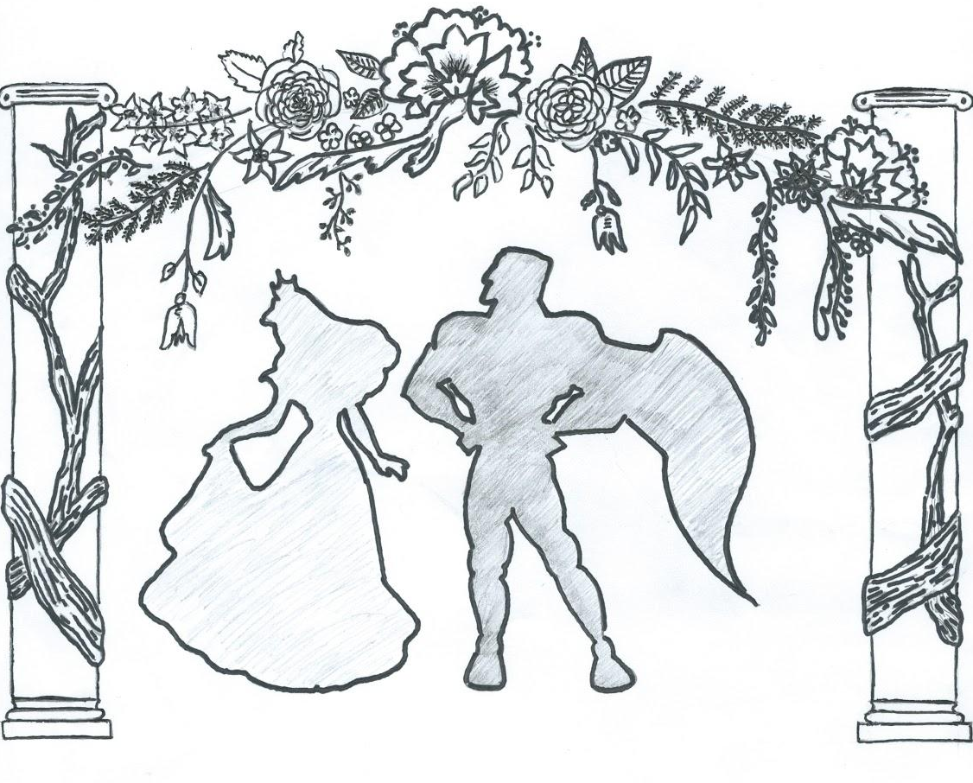
Please cut below the line and mail ticket orders with cash/check to Mrs. McHenry at Liberty High School by January 16th. Tickets will also be available for purchase at the door.
All checks should be made out to BASD MiniTHON

First Name: Last Name:

Number of tickets:

Thank you for your contribution!

What is BASD Mini-THON?
BASD Mini-THON is a fundraiser for pediatric cancer. It is modeled after Penn State’s 46 hour THON, which started in 1977 as a dance marathon to raise money for children with cancer. The THON event at Penn State is a spectacle to behold, filling the Bryce-Jordan Center with thousands of people, booming music, and a charged up student body. THON is the single largest student-run philanthropy in the world. To date, THON has raised over 100 million dollars for pediatric cancer.
Freedom and Liberty High School are planning BASD’s third annual Mini-THON on April 11th from 10am to 10 pm at Liberty High School. Students from both high schools work together year round to raise money to fight pediatric cancer. Mini-THON is an event that will allow high school students and their parents to “be a kid again”. Our Mini-THON will be filled with incredible entertainment and diverse activities for 12 hours straight while “dancers” stay on their feet for the entire event. If you want to add to the energy and help out a great cause, come to our mini-THON on March 21st to cheer on Freedom and Liberty students dancing for a cure.
The money we raise will go to Penn State’s main THON charity, the Four Diamonds Fund at Hershey Medical Center. The Fund directly assists families who have children with cancer, helping to ease their worries about the cost of treatment & medical bills.
What will be happening at the Princess and Superhero party?
During the event, there will be crafts and games available, as well as the exciting opportunity to meet Superheroes and Disney Princesses! You can sing and dance with Elsa and Anna, create a shield with Captain America, and decorate lanterns from Rapunzel’s castle. Even Ariel, Superman, and Spiderman will be there to play games! All are welcome to dress up in a favorite princess or superhero costume. Can’t wait to see you there!

* Included in the child’s ticket price of $15 is a free pass for food. Any adult interested in the food provided will be charged a meal pass of $3 upon entry.

